5/25/2018(Bharat)

==========

How to prepare disc space matrics in Jenkins

Maven release

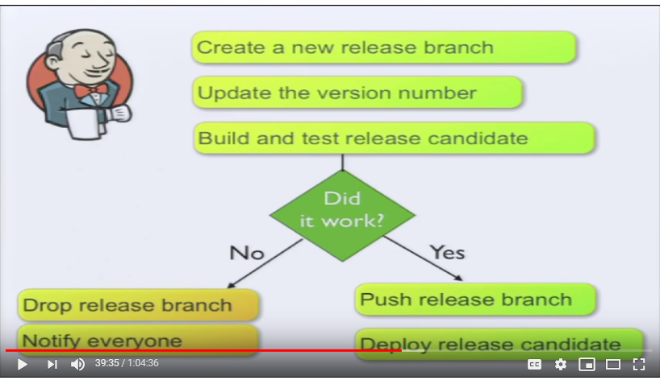

Maven version plugin

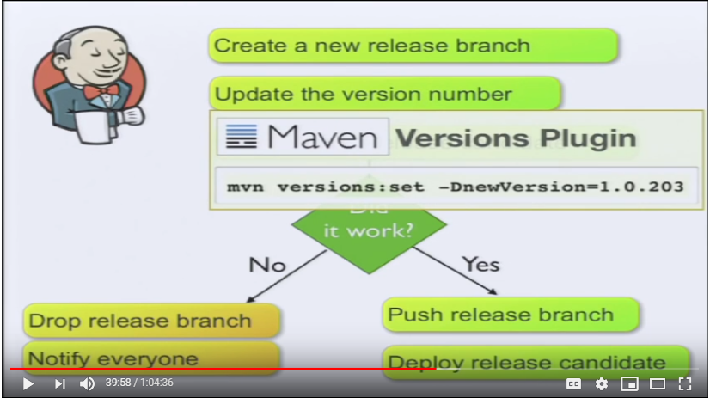

Hotfix

Git rebase and git cherry-pick

https://nvie.com/posts/a-successful-git-branching-model/

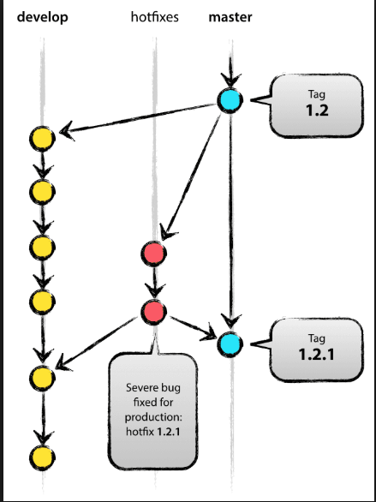

How to set global variable and use it

<https://www.youtube.com/watch?v=9r1g_idFkIs(Utube> link)

update Jenkins build status in bit bucket

<https://www.youtube.com/watch?v=uu5XcU4EPzQ>

github build status

https://stackoverflow.com/questions/14274293/show-current-state-of-jenkins-build-on-github-repo